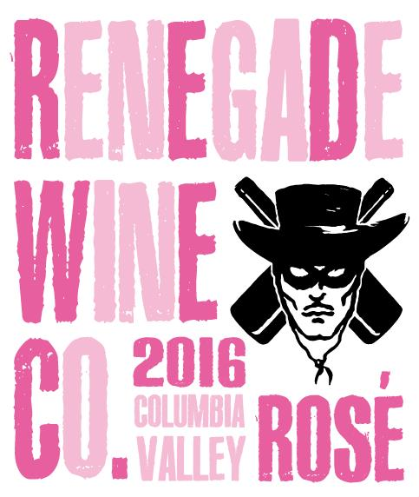

2016 Renegade wine Co. rosé
Washington state

Seattle Magazine’s Rosé of the year for 2014 and 2015

New packaging, same high quality! The 2016 Renegade Rosé is a strong follow-up to these award winning versions (we are thinking three-in-a-row). It has layers of red fruits like pomegranates, tart cherries, and juicy strawberries, with underlying minerality, all of which is balanced with fresh, crisp acidity. This mouthwatering rosé will delight all four seasons, and is a perfect pairing for outdoor bbq’s and picnic’s as well as on your dinner table. As always, it is best enjoyed with those you love the most!

69% Syrah/15% Cinsault/9% Grenache/7% Mourvèdre

3.38 pH / 6.0 g/l TA / 0.2% R.S / 12.5% Alc

